Tax Machine

Hissamuddin Shaikh

CSCI 201

30th May 2018

St. Cloud State University

**Tax Machine**

**Problem Statement**:

Calculate the amount of Federal Tax to be paid, based on the Filing Status and the Taxable Income of a user.

**Input/Output Description:**

Input: Their Filing Status, and their Taxable Income.

Output: The amount of money they need to pay in Federal Tax.

**Variables:**

* *filingtype*
  + Stores the Filing Status, under which the person is submitting their Federal Tax.
  + Type: char
* *filingamount*
  + Stores the Taxable Income that the person inputs into the program.
  + Type: float
* *taxamount*
  + Stores the amount of Federal Tax that has been calculated by the program, based on *filingamount* and *filingtype*.
  + Type: float

**Program Design:**

1. Prompt the user to insert their Filing Status.
2. Prompt the user to insert their Taxable Income.
3. Identify Tax Rate, based on their Filing Status and Taxable Income.
4. Multiply Tax Rate by Taxable Income to compute the Federal Tax amount.
5. Display the Federal Tax, with an appropriate description.

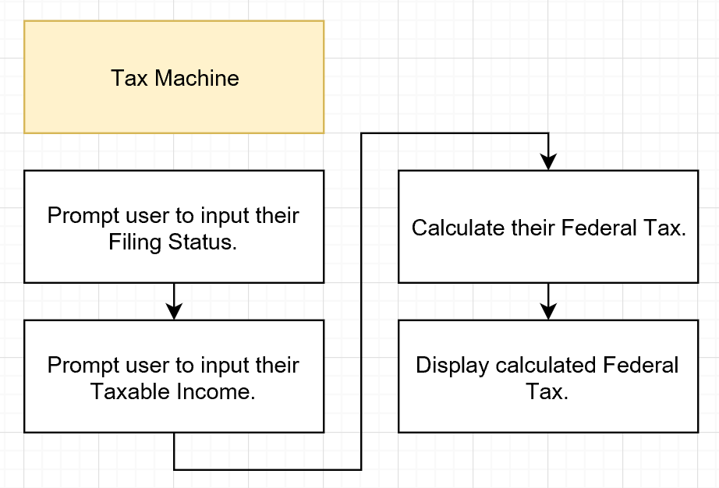**Flowchart:**

Figure. A

Note: “Calculate their Federal Tax.” is further explained below in Figure. B.

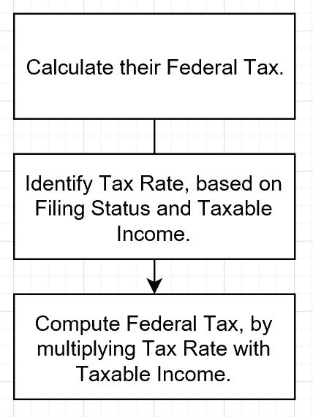

Figure. B

**Algorithm Development (Detailed Pseudocode):**

* Prompt the user to select option A, B, C or D, based on their Filing Status by displaying the following statements:

A - Single Filers

B - Married filing jointly or qualifying Widow/Widower

C - Married filing separately

D - Head of Household

Store the selected option in *filingtype*.

* Prompt the user to insert their Taxable Income, through the statement, “Please enter the amount of money (Taxable Income) that you are filing for -”. This will be stored in the variable *filingamount*.
* Through a switch statement with the value of *filingtype*,identify the Taxable Income ranges that exist for that Filing Status.
* Through an if statement, based on the range within which *filingamount* exists, identify the Tax Rate and multiply it by *filingamount*. Store the multiplied product in *taxamount*.
* Display the following, “Your Federal Tax this year, based on your income and tax-filing status, is (*taxamount*) US Dollars.”

**Program Listing:**

1. /*Tax Machine by Hissamuddin Shaikh */
2. #include <iostream>
3. #include <iomanip>
4. #include <cmath>
5. #include <string>
6. using namespace std;
7. int main()
8. {
9. /*Variable Setup*/
10. char filingtype;
11. float filingamount;
12. float taxamount;
13. /*Input Setup for Taxing Category*/
14. cout << endl <<" Tax Machine " << endl << endl;
15. cout << " A - Single Filers" << endl;
16. cout << " B - Married filing jointly or qualifying Widow/Widower" << endl;
17. cout << " C - Married filing separately" << endl;
18. cout << " D - Head of Household" <<endl << endl;
19. cout << endl <<" Please select option A, B, C or D, depending on your filing status: ";
20. cin >> filingtype;
21. /*Error Control*/
22. if (filingtype == 'a')
23. filingtype = 'A';
24. else if (filingtype == 'b')
25. filingtype = 'B';
26. else if (filingtype == 'c')
27. filingtype = 'C';
28. else if (filingtype == 'd')
29. filingtype = 'D';
30. /*Input Setup for Taxable Income*/
31. cout << endl << " Please enter the amount of money (Taxable Income) that you are filing for - ";
32. cin >> filingamount;
33. /*Setup for if statement execution, based on filing type*/
34. switch (filingtype) {
35. case 'A':
36. if (filingamount <=6000)
37. {
38. taxamount = (filingamount)*(0.10);
39. }
40. else if (filingamount <= 27950)
41. {
42. taxamount = (filingamount)*(0.15);
43. }
44. else if (filingamount <= 67700)
45. {
46. taxamount = filingamount*(0.27);
47. }
48. else if (filingamount <= 141250)
49. {
50. taxamount = filingamount*(0.30);
51. }
52. else if (filingamount <= 307050)
53. {
54. taxamount = filingamount*(0.35);
55. }
56. else
57. {
58. taxamount = filingamount*(0.386);
59. }
60. break;
61. case 'B' :
62. if (filingamount <=12000)
63. {
64. taxamount = (filingamount)*(0.10);
65. }
66. else if (filingamount <= 46700)
67. {
68. taxamount = (filingamount)*(0.15);
69. }
70. else if (filingamount <= 112850)
71. {
72. taxamount = filingamount*(0.27);
73. }
74. else if (filingamount <= 171950)
75. {
76. taxamount = filingamount*(0.30);
77. }
78. else if (filingamount <= 307050)
79. {
80. taxamount = filingamount*(0.35);
81. }
82. else
83. {
84. taxamount = filingamount*(0.386);
85. }
86. break;
87. case 'C' :
88. if (filingamount <=6000)
89. {
90. taxamount = (filingamount)*(0.10);
91. }
92. else if (filingamount <= 23350)
93. {
94. taxamount = (filingamount)*(0.15);
95. }
96. else if (filingamount <= 56425)
97. {
98. taxamount = filingamount*(0.27);
99. }
100. else if (filingamount <= 85975)
101. {
102. taxamount = filingamount*(0.30);
103. }
104. else if (filingamount <= 153525)
105. {
106. taxamount = filingamount*(0.35);
107. }
108. else
109. {
110. taxamount = filingamount*(0.386);
111. }
112. break;
113. case 'D' :
114. if (filingamount <=10000)
115. {
116. taxamount = (filingamount)*(0.10);
117. }
118. else if (filingamount <= 37450)
119. {
120. taxamount = (filingamount)*(0.15);
121. }
122. else if (filingamount <= 96700)
123. {
124. taxamount = filingamount*(0.27);
125. }
126. else if (filingamount <= 156600)
127. {
128. taxamount = filingamount*(0.30);
129. }
130. else if (filingamount <= 307050)
131. {
132. taxamount = filingamount*(0.35);
133. }
134. else
135. {
136. taxamount = filingamount*(0.386);
137. }
138. break;
139. }
140. /*Display Result*/
141. cout << endl << " Your Federal Tax this year, based on your income and tax-filing status, is "
142. << fixed << setprecision(2) << taxamount << " US Dollars."<< endl;
143. return 0;
144. }

**Note:**

Screenshots of the original code are attached at the end of the document (in the notes section), incase this is unclear.

**Sample test run of the program:**

1st Sample:

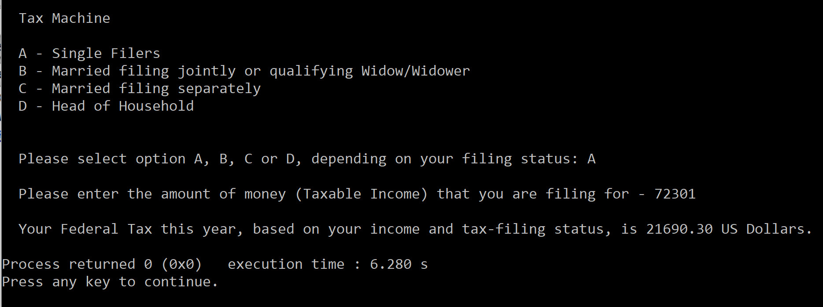

2nd Sample:

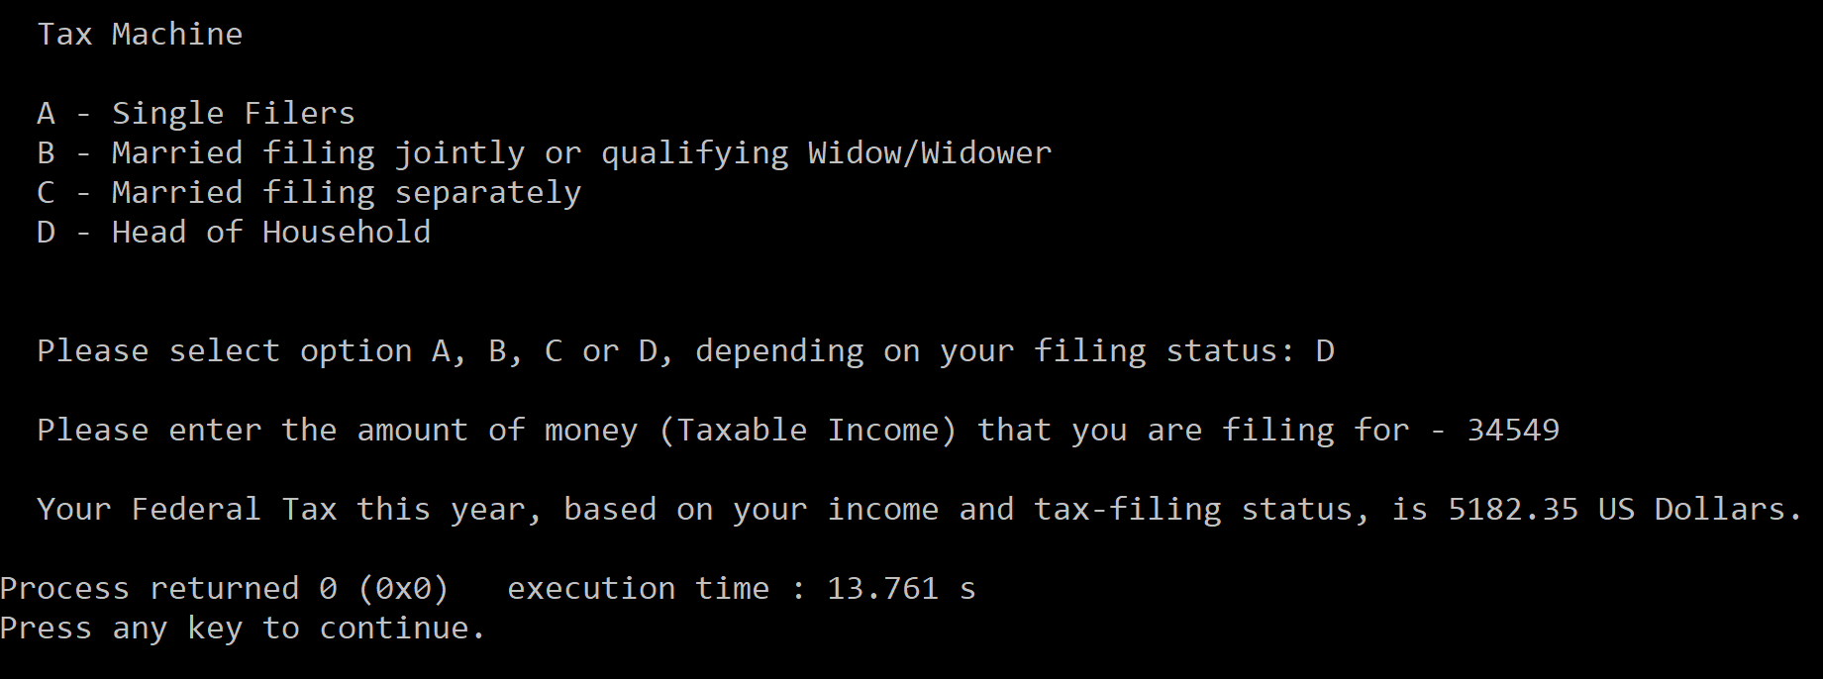

**Observations, error handling and general comments:**

The program runs correctly as the result in the 1st Sample and the 2nd Sample, correspond to manual computations.

**1st Sample (Manual Computation) =**

Filing Status: A (Single Filer)

Taxable Income: 72301

Taxable Income Range (and Corresponding Tax Rate): 67701 – 141250 (30%)

Tax Amount: (0.3*72301) = 21690.30 US Dollars

This is the same as the one computed by the computer.

**2nd Sample (Manual Computation) =**

Filing Status: D (Head of Household)

Taxable Income: 34549

Taxable Income Range (and Corresponding Tax Rate): 10,001 – 37450 (15%)

Tax Amount: (0.15*34549) = 5182.35 US Dollars

This is the same as the one computed by the computer.

No errors should be encountered at all if the user enters the amount of money and the menu option (Filing Status) in the right format. Moreover, an if statement has been setup in the program to limit the error concerning the Filing Status. It convert’s the option to uppercase in case it is entered in lowercase. For example, if I wanted to select option A, and I wrote in “a”, the if statement would convert it to “A”. Therefore, the room for error is minimal.

**Conclusions**

The Tax Machine that has been constructed in this report should serve sufficiently and efficiently, with regards to calculating the Federal Tax that needs to be paid, based on the Filing Status and Taxable Income. There is minimal room for error, as the only way this can go wrong is if the user doesn’t follow the prompt and is unable to interpret the output information.

**A screenshot of a social media post

Description generated with very high confidenceNotes:**

A screenshot of a cell phone

Description generated with very high confidence

A screenshot of a social media post

Description generated with very high confidence

A screenshot of a cell phone

Description generated with high confidence

A screenshot of a computer

Description generated with very high confidence

A screenshot of a social media post

Description generated with very high confidence